**Web Technology Applications**

Assignment-1

**1.Write a JavaScript to design a simple calculator to perform the following operations: sum, product, difference and quotient**

<!DOCTYPE html>

<html>

<head>

<script>

//function that display value

function dis(val)

{

document.getElementById("result").value+=val

}

//function that evaluates the digit and return result

function solve()

{

let x = document.getElementById("result").value

let y = eval(x)

document.getElementById("result").value = y

}

//function that clear the display

function clr()

{

document.getElementById("result").value = ""

}

</script>

<!-- for styling -->

<style>

.title{

margin-bottom: 10px;

text-align:center;

width: 182px;

color:green;

border: solid black 2px;

}

input[type="button"]

{

background-color:gray;

color: black;

border: solid black 2px;

width:100%

}

input[type="text"]

{

background-color:white;

border: solid black 2px;

width: 95%

}

</style>

</head>

<!-- create table -->

<body>

<div class = title > Calculator</div>

<table border="1">

<tr>

<td colspan="4"><input type="text" id="result"/></td>

<!-- clr() function will call clr to clear all value -->

</tr>

<tr>

<!-- create button and assign value to each button -->

<!-- dis("1") will call function dis to display value -->

<td><input type="button" value="1" onclick="dis('1')"/> </td>

<td><input type="button" value="2" onclick="dis('2')"/> </td>

<td><input type="button" value="3" onclick="dis('3')"/> </td>

<td><input type="button" value="/" onclick="dis('/')"/> </td>

</tr>

<tr>

<td><input type="button" value="4" onclick="dis('4')"/> </td>

<td><input type="button" value="5" onclick="dis('5')"/> </td>

<td><input type="button" value="6" onclick="dis('6')"/> </td>

<td><input type="button" value="-" onclick="dis('-')"/> </td>

</tr>

<tr>

<td><input type="button" value="7" onclick="dis('7')"/> </td>

<td><input type="button" value="8" onclick="dis('8')"/> </td>

<td><input type="button" value="9" onclick="dis('9')"/> </td>

<td><input type="button" value="+" onclick="dis('+')"/> </td>

</tr>

<tr>

<td><input type="button" value="C" onclick="dis('c')"/> </td>

<td><input type="button" value="0" onclick="dis('0')"/> </td>

<!-- solve function call function solve to evaluate value -->

<td><input type="button" value="=" onclick="solve()"/> </td>

<td><input type="button" value="*" onclick="dis('*')"/> </td>

</tr>

</table>

</body>

</html>

Output:

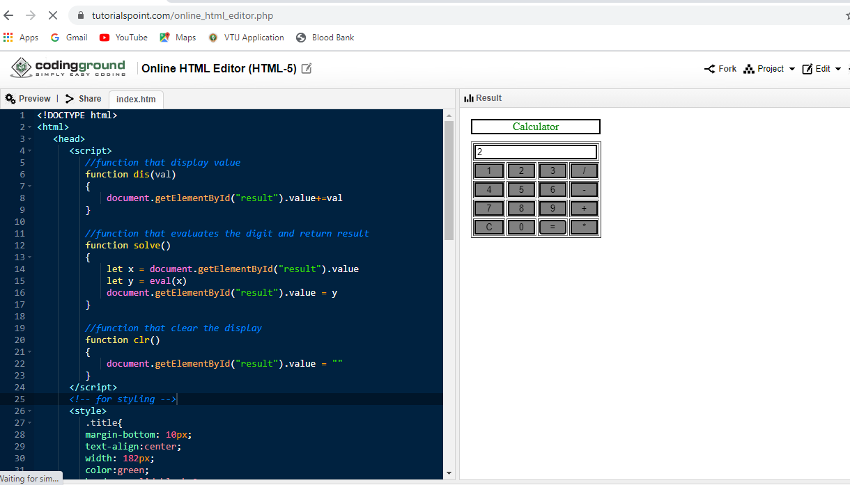

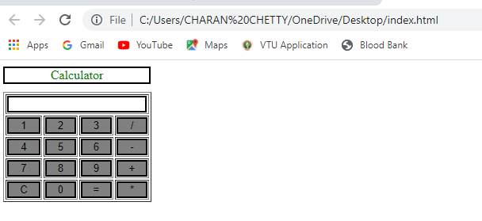

4. Test cases:

|  |  |  |  |  |
| --- | --- | --- | --- | --- |
| Test No. | Input  Parameters | Expected Output | Obtained Output | Remarks |
| 1.            2. | value1=49  value2=3  value1= 0  value2=45 | Addition = 52 | Addition =52 | PASS |
| Subtraction =46 | Subtraction =46 |
| Multiplication=147 | Multiplication=147 |
| Division=16.33 | Division=2. Division=16.33 |
| Addition =45 | Addition =45 | PASS |
| Subtraction =-45 | Subtraction =-45 |
| Multiplication=0 | Multiplication=0 |
| Division=0 | Division=0 |
| 3. | value1=678  value2=200 | Addition =878 | Addition =878 | PASS |
| Subtraction = 478 | Subtraction =478 |
| Multiplication=135600 | Multiplication=135600 |
| Division= 3.39 | Division=3.39 |
| 4. | value1 =a  value2 =32 | ENTER VALID NUMBER | ENTER VALID NUMBER | PASS |